***Task #1***

**Defect finding**

*Screen 1:*

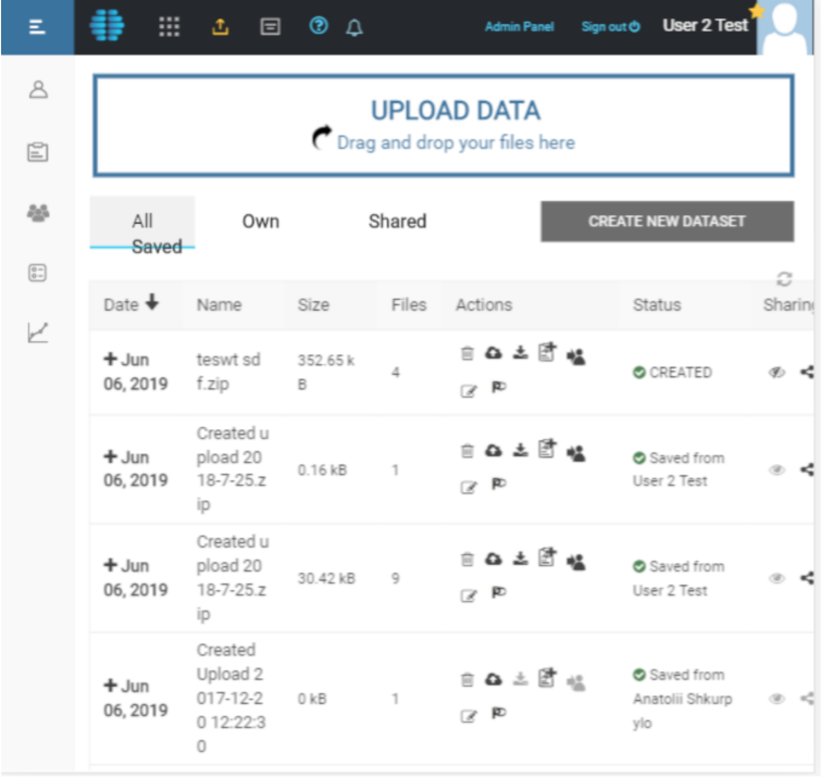

Find and describe all defect on the form below;

**Bug report. Some name of the application.** (Andrey Dorokhin)

|  |  |
| --- | --- |
| **ID number** | #0001 |
| **Summary** | Wrong position of the buttons on the top bar |
| **Description** | The buttons on the top bar have different distances between themselves and different indents from the top |
| **Reporter** | Dorokhin A |
| **Submit Date** | 11.06.2019 |
| **Component** | Upload data page |
| **Severity** | Minor |
| **Priority** | Medium |
| **Assigned to** | / |
| **Status** | New |
| **Environment** | OS – Android 8.1 |
| **Steps to Reproduce** | 1. Open “Name of app”;  2. Click “Upload data page”. |
| **Actual Result** | The buttons on the top bar have different distances between themselves and different indents from the top. |
| **Expected Result** | The buttons on the top bar should have the same distance between them and the same indents from the top. |
| **Attachment** | Screenshot: <http://joxi.net/5mdxeL8U3K9bXm> |

|  |  |
| --- | --- |
| **ID number** | #0002 |
| **Summary** | Wrong position of the star on the top bar |
| **Description** | The star on the top bar is superimposed over the user's avatar |
| **Reporter** | Dorokhin A |
| **Submit Date** | 11.06.2019 |
| **Component** | Upload data page |
| **Severity** | Minor |
| **Priority** | Medium |
| **Assigned to** | / |
| **Status** | New |
| **Environment** | OS – Android 8.1 |
| **Steps to Reproduce** | 1. Open “Name of app”;  2. Click “Upload data page”. |
| **Actual Result** | The star on the top bar is superimposed over the user's avatar. |
| **Expected Result** | The star on the top bar should be between the username and his avatar. |
| **Attachment** | Screenshot: <http://joxi.net/a2X6v9pHw7PEMr> |

|  |  |
| --- | --- |
| **ID number** | #0003 |
| **Summary** | Wrong position of the text on the button “All saved”. |
| **Description** | The text on the button “All saved” is off center and extends beyond the borders of the button. |
| **Reporter** | Dorokhin A |
| **Submit Date** | 11.06.2019 |
| **Component** | Upload data page |
| **Severity** | Minor |
| **Priority** | Medium |
| **Assigned to** | / |
| **Status** | New |
| **Environment** | OS – Android 8.1 |
| **Steps to Reproduce** | 1. Open “Name of app”;  2. Click “Upload data page”. |
| **Actual Result** | The text on the button “All saved” is off center and extends beyond the borders of the button. |
| **Expected Result** | The text on the button “All saved” should be centered and fully fit into the cell. |
| **Attachment** | Screenshot: <http://joxi.net/Dr8lVB8topRN5r> |

|  |  |
| --- | --- |
| **ID number** | #0004 |
| **Summary** | Wrong placement of the table on the page. |
| **Description** | Different indents to the left and right of the table. |
| **Reporter** | Dorokhin A |
| **Submit Date** | 11.06.2019 |
| **Component** | Upload data page |
| **Severity** | Minor |
| **Priority** | Medium |
| **Assigned to** | / |
| **Status** | New |
| **Environment** | OS – Android 8.1 |
| **Steps to Reproduce** | 1. Open “Name of app”;  2. Click “Upload data page”. |
| **Actual Result** | Different indents to the left and right of the table. |
| **Expected Result** | The table should have the same padding on the left and right. |
| **Attachment** | Screenshot: <http://joxi.net/52aOV64hEW19Qr> |

|  |  |
| --- | --- |
| **ID number** | #0005 |
| **Summary** | The text of the column name “Date” has a wrong format. |
| **Description** | The name of the table column “Date” with an arrow is not centered and the arrow has a different color. |
| **Reporter** | Dorokhin A |
| **Submit Date** | 11.06.2019 |
| **Component** | Upload data page |
| **Severity** | Minor |
| **Priority** | Medium |
| **Assigned to** | / |
| **Status** | New |
| **Environment** | OS – Android 8.1 |
| **Steps to Reproduce** | 1. Open “Name of app”;  2. Click “Upload data page”. |
| **Actual Result** | The name of the table column “Date” with an arrow is not centered and the arrow has a different color. |
| **Expected Result** | The name of the table column “Date” with an arrow should be centered and have the same color. |
| **Attachment** | Screenshot: <http://joxi.net/Rmza3GWcYdaWXr> |

|  |  |
| --- | --- |
| **ID number** | #0006 |
| **Summary** | The text of the table column “Sharing” does not fit in the cell. |
| **Description** | The name of the table column “Sharing” with its icon does not fit in the cell and go beyond it. |
| **Reporter** | Dorokhin A |
| **Submit Date** | 11.06.2019 |
| **Component** | Upload data page |
| **Severity** | Minor |
| **Priority** | Medium |
| **Assigned to** | / |
| **Status** | New |
| **Environment** | OS – Android 8.1 |
| **Steps to Reproduce** | 1. Open “Name of app”;  2. Click “Upload data page”. |
| **Actual Result** | The name of the table column “Sharing” with its icon does not fit in the cell and go beyond it. |
| **Expected Result** | The name of the table column “Sharing” with its icon should be centered and fully fit into the cell. |
| **Attachment** | Screenshot: <http://joxi.net/12M8v9MCl754Zm> |

|  |  |
| --- | --- |
| **ID number** | #0007 |
| **Summary** | Incorrect text wrap in cells. |
| **Description** | Incorrect text wrap in cells of the table columns “Name”, “Size”. |
| **Reporter** | Dorokhin A |
| **Submit Date** | 11.06.2019 |
| **Component** | Upload data page |
| **Severity** | Minor |
| **Priority** | Medium |
| **Assigned to** | / |
| **Status** | New |
| **Environment** | OS – Android 8.1 |
| **Steps to Reproduce** | 1. Open “Name of app”;  2. Click “Upload data page”. |
| **Actual Result** | Incorrect text wrap in cells of the table columns “Name”, “Size”. |
| **Expected Result** | When wrapping text in cells of the table columns “Name”, “Size”, words should not be broken. |
| **Attachment** | Screenshot: <http://joxi.net/D2Pqv9WIqYLp8A> |

|  |  |
| --- | --- |
| **ID number** | #0008 |
| **Summary** | The icons in the "Actions" column have the wrong position. |
| **Description** | The icons in the cells of the corresponding column of the table “Actions” have different indents from the top edge. |
| **Reporter** | Dorokhin A |
| **Submit Date** | 11.06.2019 |
| **Component** | Upload data page |
| **Severity** | Minor |
| **Priority** | Medium |
| **Assigned to** | / |
| **Status** | New |
| **Environment** | OS – Android 8.1 |
| **Steps to Reproduce** | 1. Open “Name of app”;  2. Click “Upload data page”. |
| **Actual Result** | The icons in the cells of the corresponding column of the table “Actions” have different indents from the top edge. |
| **Expected Result** | The icons in the cells of the corresponding column of the table “Actions” should have the same indents from the top edge. |
| **Attachment** | Screenshot: <http://joxi.net/D2Pqv9WIqYLq8A> |

|  |  |
| --- | --- |
| **ID number** | #0009 |
| **Summary** | The icons in the "Sharing" column have different color. |
| **Description** | The icons in the cells of the corresponding column of the table “Sharing” have different color. |
| **Reporter** | Dorokhin A |
| **Submit Date** | 11.06.2019 |
| **Component** | Upload data page |
| **Severity** | Minor |
| **Priority** | Medium |
| **Assigned to** | / |
| **Status** | New |
| **Environment** | OS – Android 8.1 |
| **Steps to Reproduce** | 1. Open “Name of app”;  2. Click “Upload data page”. |
| **Actual Result** | The icons in the cells of the corresponding column of the table “Sharing” have different color. |
| **Expected Result** | The icons in the cells of the corresponding column of the table “Sharing” should have the same color. |
| **Attachment** | Screenshot: <http://joxi.net/4AkJjnbio5zoQ2> |